Complaints in respect of supervisory practice of FiP members

1. Scope
This process is open to psychotherapy practitioners working with individual adult clients who have a complaint relating to the supervision practice of a FiP member.
FiP’s supervision complaints process does not operate in respect of FiP’s clinical associate members whose practice is not registered in respect of the practice labels of UKCP/CPJA to which FiP accredits members. Nor does it operate in respect of the supervisory activities of full clinical or non-clinical members in respect of their supervision of work that is not with individual adult clients.
Complainants seeking to complain about the supervisory practice of non-UKCP registered FiP members or supervision other than regarding psychotherapy with individual adult clients, will be guided toward pursuing their complaint with the relevant registering body, college or training institution.

2. Making a complaint
A supervisee with a complaint within the scope described above should write to the chair of FiP’s ethics sub-committee entitling their letter ‘Supervision Complaint. The letter should be sent care of FiP’s administrator either to our registered office or via email. The address details are as follows:
email: administrator@fip.org.uk,
or by post to
Head of FiP ethics sub-committee
c/o FiP Administrator, 66 Smirrells Road, Hall Green, Birmingham B28 0LB.

The letter should set out the basis of the complaint in reasonable detail and, where possible, should indicate the outcome that is being sought. The complaint should make clear the nature of the work being supervised. It is helpful if telephone and/or email details are provided so that the complainant can be contacted if any clarification is required in order to process the complaint.
The letter will be acknowledged within 7 days of receipt.

3. Complaints process

3.1 Initial review
The chair of the ethics sub-committee will review the membership status of the FiP member against whom the complaint has been made and the nature of the work being supervised. The aim of this initial review is to determine whether it is within the scope of FiP’s process.
If the complaint is within scope it will be subject to the investigation of its substance.
If the complaint is not within scope the chair will communicate this in writing to the complainant with an explanation of the decision. Where possible, the claimant will be directed to an appropriate other body to pursue their concerns (which might be another registering body, UKCP college or, in the case of a trainee supervisee, their training organisation).
The aim is to complete the review of scope and communicate the outcome within 14 days of receipt of the complaint.

3.2 Substance review

3.2.1 Outline
If the complaint is within scope the chair of the ethics committee will appoint an independent, senior FiP member with appropriate supervisory experience to make an initial assessment of the substance of the complaint; if necessary contacting the complainant for clarification.
The possible outcomes of this assessment of substance are:
- The matter may be able to be resolved informally.
- The complaint is of a nature that FiP believes should be escalated to UKCP’s clinical complaints process.
- The complaint should be considered following FiP’s organisational complaints process.
The aim will be to complete the substance review within 28 days of receipt of the complaint.

3.2.2 Informal resolution
If on the basis of the information in the complaint the concerns appear to be relatively trivial or to be based on a misunderstanding, both the complainant and the member being complained about will be contacted to determine if both are willing to resolve the matter informally.
The member performing the substance review will be asked to facilitate the informal resolution.

3.2.3 Escalation to UKCP
The UKCP complaints and conduct process provides a process for considering complaints or concerns from members of the public and clients about therapists. Whilst the emphasis is on the client/therapist relationship, the process is also framed to protect the public good.
The following is an extract from UKCP’s information in respect of its complaints and conduct process (emphasis added):
We aim to ensure that the therapists on our register:
- have the skills, knowledge and character to work safely and effectively with clients
- behave in a way that safeguards public safety and maintains confidence in the psychotherapy profession.
We will look into cases where there is evidence that calls into question a therapist’s suitability to be on our register. Examples of this include instances where a therapist may have:
- been dishonest
- behaved in a way that causes harm or distress to a client
- breached client confidentiality.
We will also consider complaints about a therapist who is unable to meet our professional standards because of a health problem or a drug or alcohol problem.
Where complaints are of a nature that would fall within the scope of the public good reflected in the above extract and which, if upheld, might temporarily or permanently impact a member’s registered status, FiP does not believe it has the resources to oversee a sufficiently robust investigation and determination. FiP would also be concerned that it does not have the jurisdiction to enforce the type of sanctions that might be appropriate.
Where the nature of the complaint received is such that it carries potential implications in respect of the supervisor’s broader suitability to be on the UKCP register, FiP will consult with UKCP to determine the appropriateness of the complainant being directed to their process.
The outcome of this consultation will be communicated to the supervisee who has raised the complaint and to the member being complained about in order to confirm the process (i.e. UKCP or FiP) via which the complaint should be pursued. The aim will be to communicate such a decision within 28 days of receiving the complaint, but precise timings are dependent on consultation with UKCP.

3.2.4 FiP’s complaints process
If the complaint against a member in respect of their supervisory practice is within scope and its substance judged as within the range of issues FiP considers itself able to adjudicate, the chair of the ethics sub-committee will initiate the investigation and panel review stages of FiP’s complaints process:

Investigation
The chair of FiP’s ethics sub-committee will appoint a suitable investigator from within the ethics sub-committee to undertake the necessary investigation. The chair of the ethics sub-committee will consider any potential for conflicts of interest arising at this or subsequent stages in the process.
The independent investigator will gather evidence and seek a clear understanding of the circumstances of the complaint through discussions with relevant parties including the complainant.
The aim will be to complete the investigation within 42 days of the complaint being acknowledged.
Review Panel
Initial investigations are managed by the chair of FiP’s ethics sub-committee who will then advise the board of the need to establish a review panel to assess the complaint.
- Two senior FiP members (i.e. having greater than 5 years post registration experience), both independent of the member whose supervision activities are being complained about, will be appointed by the board to form a review panel. One of the panel members will be an experienced supervisor.
- The panel members will liaise with the investigator who will brief them on findings to date.
- The complainant will be given a timescale for the review panel. The aim is to hold the panel within 56 days of receiving the complaint. Where possible the panel members will meet with the complainant, in person or online. If this is impossible the review may be conducted via written exchanges.
- Within 14 days of sitting the review panel will produce a report setting out their conclusions and recommendations for redress to the complainant and/or sanctions. N.B It is not within the scope of FiP to calculate or award compensation to complainants. Such considerations would have to be referred to the member’s professional insurers.
- When complete, the report, including any recommendations, will be sent to the chair of the ethics sub-committee.
Executive summary and board presentation
- The chair of the ethics sub-committee will present a summary to the FiP board of the outcome and recommendations in the report (but not at this stage the detail of the evidence considered in order to preserve the independence of members of the board who may be involved in any appeal)
- The board will consider the conclusions and recommendations. If they require any further investigations they will request the investigator and panel undertake them otherwise they will sign off on the report.
- The chair of the ethics sub-committee will write to the complainant and the member being complained about with a summary of the outcome and recommendations.
- If the decision is accepted by both parties, the agreed actions will be taken. If either party is dissatisfied with the decision they may request that an appeal process be instituted.
Subject to a possible appeal, the aim is to complete the complaints process within 90 days of receiving the complaint – precise timings will however be subject to an available board meeting.
Appeal
If one of the parties to the complaint is dissatisfied with the outcome of the complaints process, they may seek to appeal against the conclusion and recommendations. The appeal should be in writing and addressed to the chair of FiP c/o FiP’s administrator (administrator@fip.org.uk).
Any appeal must be lodged within 14 days of the outcome being communicated. Receipt of an appeal will be acknowledged within 7 days.
Appeals will only be accepted if either party can show that proper procedure has not been followed or that there is new information to support their case that was not previously available.
The chair will review the detailed investigation and panel reports and seek any clarification required. Before considering an appeal decision the chair of FiP will consider whether any external advice or adjudication is necessary.
The outcome of this appeal is final as regards FiP’s complaints process.
The aim is to complete an appeal review and respond to the parties within 28 days. If this is not going to be possible, for example if external expertise needs to be consulted, the chair will communicate the delay to the parties.
If at the end of FiP’s appeal process, the organisation has failed to address the complainant’s concerns, they can raise a complaint with UKCP by completing the UKCP form ‘Reporting a complaint about an organisational member of UKCP’.

3.3 FiP’s support for its member
In addition to its important role processing complaints from supervisees who are members of FiP, FiP also exists to provide advice and support to its members. A supervising member subject to a complaint from a supervisee is entitled to seek support and advice by contacting, in the first instance, the chair of FiP’s ethics sub-committee. The chair of FiP’s ethics sub-committee will identify a suitable member who, independently of the complaints process, can provide support to the member.
Members alerted to a complaint regarding their supervisory practice should also consider the obligation to consult their professional insurer and the potential for support/advice from that quarter.

Supervisory complaints procedure – flowchart

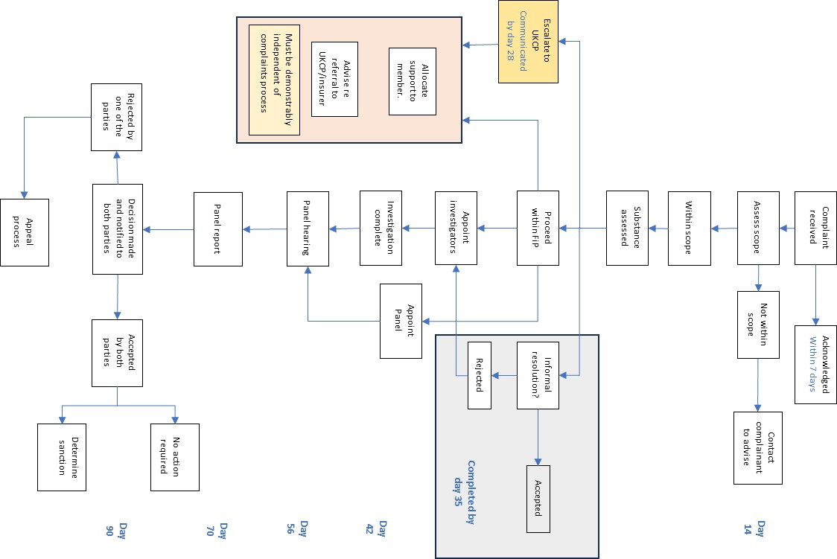

Page intentionally blank

